**EXPERIMENT 5**

**PROGRAMS:**

1. **Create a flask app for contact page**

**main.py**

import csv

from flask import Flask, render_template, request, redirect, url_for

from forms import ContactForm

import pandas as pd

app = Flask(__name__)

app.config['SECRET_KEY'] = 'sakshiexp5'

# Contact form route

@app.route('/', methods=['GET', 'POST'])

def contactfunc():

form = ContactForm()

if request.method == "POST":

name = form.name.data

email = form.email.data

subject = form.subject.data

message = form.message.data

# Write form data to CSV file

with open('contact_data.csv', mode='a', newline='') as csv_file:

fieldnames = ['name', 'email', 'subject', 'message']

writer = csv.DictWriter(csv_file, fieldnames=fieldnames)

writer.writerow({'name': name, 'email': email,

'subject': subject, 'message': message})

return redirect(url_for('thank_you'))

return render_template('contact.html', form=form)

@app.route('/thankyou')

def thank_you():

return render_template('thankyou.html')

if __name__ == '__main__':

app.run(debug=True)

**forms.py**

from flask_wtf import FlaskForm

from wtforms import StringField, TextAreaField, SubmitField

class ContactForm(FlaskForm):

name = StringField('Name')

email = StringField('Email')

subject = StringField('Subject')

message = TextAreaField('Message')

submit = SubmitField('Send')

**contact.html**

<body>

<div class="contact">

<h3>CONTACT US FORM</h3>

<form action="{{ url_for('contactfunc') }}" method="post">

<div>

<p>

{{ form.name.label }}

<br />

{{ form.name(placeholder="Enter your Name") }}

</p>

<p>

{{ form.email.label }} <br />

{{ form.email(placeholder="Enter your Email ID") }}

</p>

<p>

{{ form.subject.label }}<br />

{{form.subject(placeholder="Enter the Subject")}}

</p>

<p>

{{ form.message.label }}<br />

{{ form.message(placeholder="Enter your message") }}

</p>

<p>{{ form.submit }}</p>

</div>

</form>

</div>

</body>

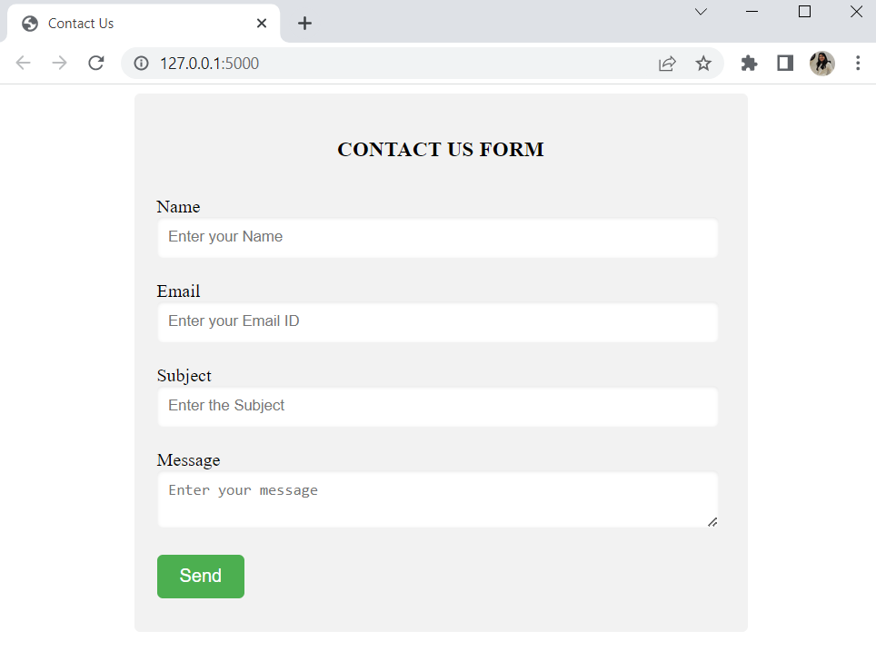

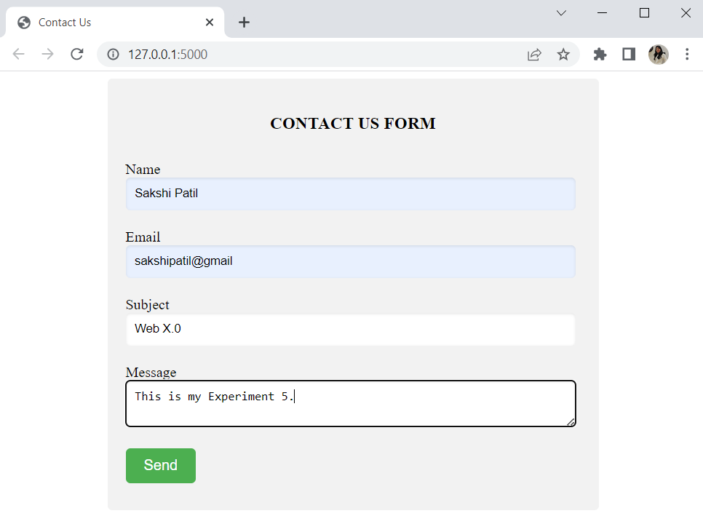

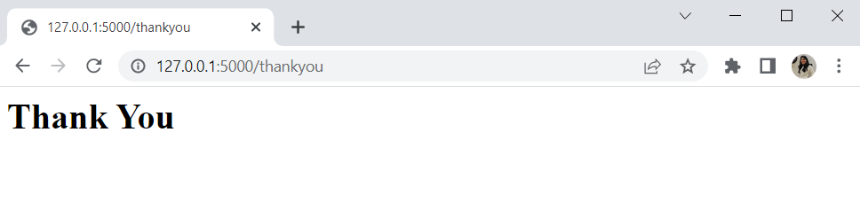

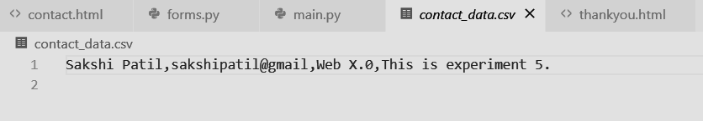

1. **Create a portfolio with contact us**

**main.py**

import csv

from flask import Flask, render_template, request, redirect, url_for

from forms import ContactForm

import pandas as pd

app = Flask(__name__)

app.config['SECRET_KEY'] = 'sakshiexp5'

# Contact form route

@app.route('/contactme', methods=['GET', 'POST'])

def contactfunc():

form = ContactForm()

if request.method == "POST":

name = form.name.data

email = form.email.data

subject = form.subject.data

message = form.message.data

# Write form data to CSV file

with open('contact_data.csv', mode='a', newline='') as csv_file:

fieldnames = ['name', 'email', 'subject', 'message']

writer = csv.DictWriter(csv_file, fieldnames=fieldnames)

writer.writerow({'name': name, 'email': email,

'subject': subject, 'message': message})

return redirect(url_for('thank_you'))

return render_template('contact.html', form=form)

@app.route('/thankyou')

def thank_you():

return render_template('thankyou.html')

@app.route('/portfolio')

def portfolio():

return render_template('portfolio.html')

if __name__ == '__main__':

app.run(debug=True)

**portfolio.html**

<body>

<!-- Header -->

<section id="header">

<div class="header container">

<div class="nav-bar">

<div class="brand">

<a href="#hero"><h1>MY PORTFOLIO</h1></a>

</div>

<div class="nav-list">

<div class="hamburger"><div class="bar"></div></div>

<ul>

<li><a href="#about" data-after="About">About</a></li>

<li><a href="#contact" data-after="Contact">Contact Me</a></li>

</ul>

</div>

</div>

</div>

</section>

<!-- End Header -->

<!-- Hero Section -->

<section id="hero">

<div class="hero container">

<div>

<h1>Hello, <span></span></h1>

<h1>Welcome To <span></span></h1>

<h1>TCR INNOVATION <span></span></h1>

<a href="#projects" type="button" class="cta">Portfolio</a>

</div>

</div>

</section>

<!-- End Hero Section -->

<!-- Service Section -->

<section id="services">

<div class="services container">

<div class="service-top">

<h1 class="section-title">Serv<span>i</span>ces</h1>

<p>Lorem ipsum dolor sit amet consectetur, adipisicing elit. Ipsum deleniti maiores pariatur assumenda quas magni et, doloribus quod voluptate quasi molestiae magnam officiis dolorum, dolor provident atque molestias voluptatum explicabo!</p>

</div>

<div class="service-bottom">

<div class="service-item">

<div class="icon"><img src="https://img.icons8.com/bubbles/100/000000/services.png"/></div>

<h2>Web Design</h2>

<p>Lorem ipsum dolor sit amet consectetur adipisicing elit. Corporis debitis rerum, magni voluptatem sed architecto placeat beatae tenetur officia quod</p>

</div>

<div class="service-item">

<div class="icon"><img src="https://img.icons8.com/bubbles/100/000000/services.png"/></div>

<h2>Web Design</h2>

<p>Lorem ipsum dolor sit amet consectetur adipisicing elit. Corporis debitis rerum, magni voluptatem sed architecto placeat beatae tenetur officia quod</p>

</div>

<div class="service-item">

<div class="icon"><img src="https://img.icons8.com/bubbles/100/000000/services.png"/></div>

<h2>Web Design</h2>

<p>Lorem ipsum dolor sit amet consectetur adipisicing elit. Corporis debitis rerum, magni voluptatem sed architecto placeat beatae tenetur officia quod</p>

</div>

<div class="service-item">

<div class="icon"><img src="https://img.icons8.com/bubbles/100/000000/services.png"/></div>

<h2>Web Design</h2>

<p>Lorem ipsum dolor sit amet consectetur adipisicing elit. Corporis debitis rerum, magni voluptatem sed architecto placeat beatae tenetur officia quod</p>

</div>

</div>

</div>

</section>

<!-- End Service Section -->

<!-- Projects Section -->

<section id="projects">

<div class="projects container">

<div class="projects-header">

<h1 class="section-title">Recent <span>Projects</span></h1>

</div>

<div class="all-projects">

<div class="project-item">

<div class="project-info">

<h1>Project 1</h1>

<h2>Coding is Love</h2>

<p>Lorem, ipsum dolor sit amet consectetur adipisicing elit. Ad, iusto cupiditate voluptatum impedit unde rem ipsa distinctio illum quae mollitia ut, accusantium eius odio ducimus illo neque atque libero non sunt harum? Ipsum repellat animi, fugit architecto voluptatum odit et!</p>

</div>

<div class="project-img">

<img src="./img/img-1.png" alt="img">

</div>

</div>

<div class="project-item">

<div class="project-info">

<h1>Project 2</h1>

<h2>Coding is Love</h2>

<p>Lorem, ipsum dolor sit amet consectetur adipisicing elit. Ad, iusto cupiditate voluptatum impedit unde rem ipsa distinctio illum quae mollitia ut, accusantium eius odio ducimus illo neque atque libero non sunt harum? Ipsum repellat animi, fugit architecto voluptatum odit et!</p>

</div>

<div class="project-img">

<img src="./img/img-1.png" alt="img">

</div>

</div>

<div class="project-item">

<div class="project-info">

<h1>Project 3</h1>

<h2>Coding is Love</h2>

<p>Lorem, ipsum dolor sit amet consectetur adipisicing elit. Ad, iusto cupiditate voluptatum impedit unde rem ipsa distinctio illum quae mollitia ut, accusantium eius odio ducimus illo neque atque libero non sunt harum? Ipsum repellat animi, fugit architecto voluptatum odit et!</p>

</div>

<div class="project-img">

<img src="./img/img-1.png" alt="img">

</div>

</div>

<div class="project-item">

<div class="project-info">

<h1>Project 4</h1>

<h2>Coding is Love</h2>

<p>Lorem, ipsum dolor sit amet consectetur adipisicing elit. Ad, iusto cupiditate voluptatum impedit unde rem ipsa distinctio illum quae mollitia ut, accusantium eius odio ducimus illo neque atque libero non sunt harum? Ipsum repellat animi, fugit architecto voluptatum odit et!</p>

</div>

<div class="project-img">

<img src="./img/img-1.png" alt="img">

</div>

</div>

<div class="project-item">

<div class="project-info">

<h1>Project 5</h1>

<h2>Coding is Love</h2>

<p>Lorem, ipsum dolor sit amet consectetur adipisicing elit. Ad, iusto cupiditate voluptatum impedit unde rem ipsa distinctio illum quae mollitia ut, accusantium eius odio ducimus illo neque atque libero non sunt harum? Ipsum repellat animi, fugit architecto voluptatum odit et!</p>

</div>

<div class="project-img">

<img src="./img/img-1.png" alt="img">

</div>

</div>

</div>

</div>

</section>

<!-- End Projects Section -->

<!-- About Section -->

<section id="about">

<div class="about container">

<div class="col-left">

<div class="about-img">

<img src="./sakshipic.jpeg" alt="img">

</div>

</div>

<div class="col-right">

<h1 class="section-title">About <span>me</span></h1>

<h2>Data Science Enthusiast</h2>

<p>I am an Engineering Student, 3rd Year at Vivekanand Education Society's Institute of Technology.</p>

<p>As a Machine Learning enthusiast, I am deeply fascinated by the potential of artificial intelligence to transform our world. My passion for the field is driven by the ability to solve complex problems through data-driven approaches, and the constant exploration of cutting-edge techniques and tools. I have a strong foundation in mathematics, statistics, and programming, which allows me to design and implement algorithms for a wide range of applications. I thrive on challenging projects that require creativity and innovation, and I am always eager to learn and collaborate with other like-minded individuals to make a meaningful impact in the world of machine learning.</p>

<a href="#" class="cta">Download Resume</a>

</div>

</div>

</section>

<!-- End About Section -->

<!-- Footer -->

<section id="footer">

<div class="footer container">

<div class="brand"><h1><span>SAKSHI PATIL</h1></div>

<h2>Your Complete Web Solution</h2>

<div class="social-icon">

<div class="social-item">

<a href="#"><img src="https://img.icons8.com/bubbles/100/000000/facebook-new.png"/></a>

</div>

<div class="social-item">

<a href="#"><img src="https://img.icons8.com/bubbles/100/000000/instagram-new.png"/></a>

</div>

<div class="social-item">

<a href="#"><img src="https://img.icons8.com/bubbles/100/000000/behance.png"/></a>

</div>

</div>

<p>Copyright © 2020. All rights reserved</p>

</div>

</section>

<!-- End Footer -->

</body>

